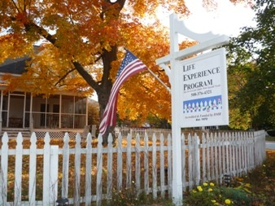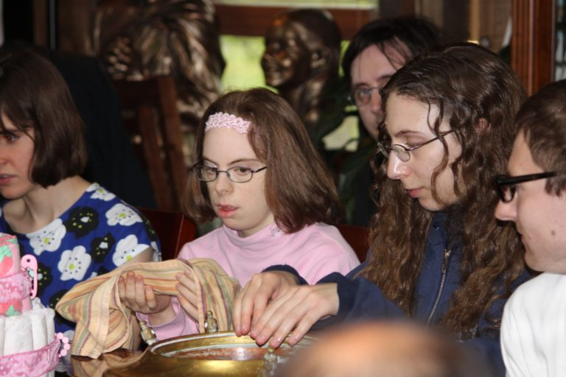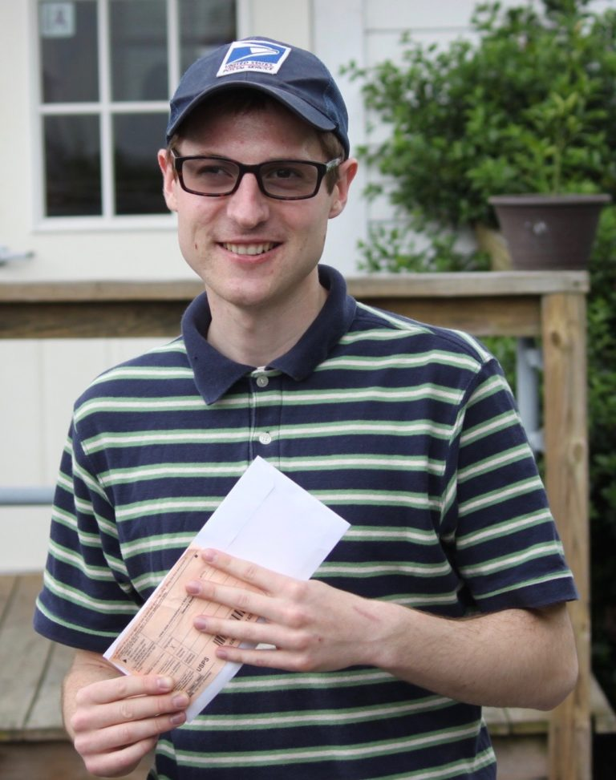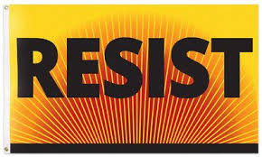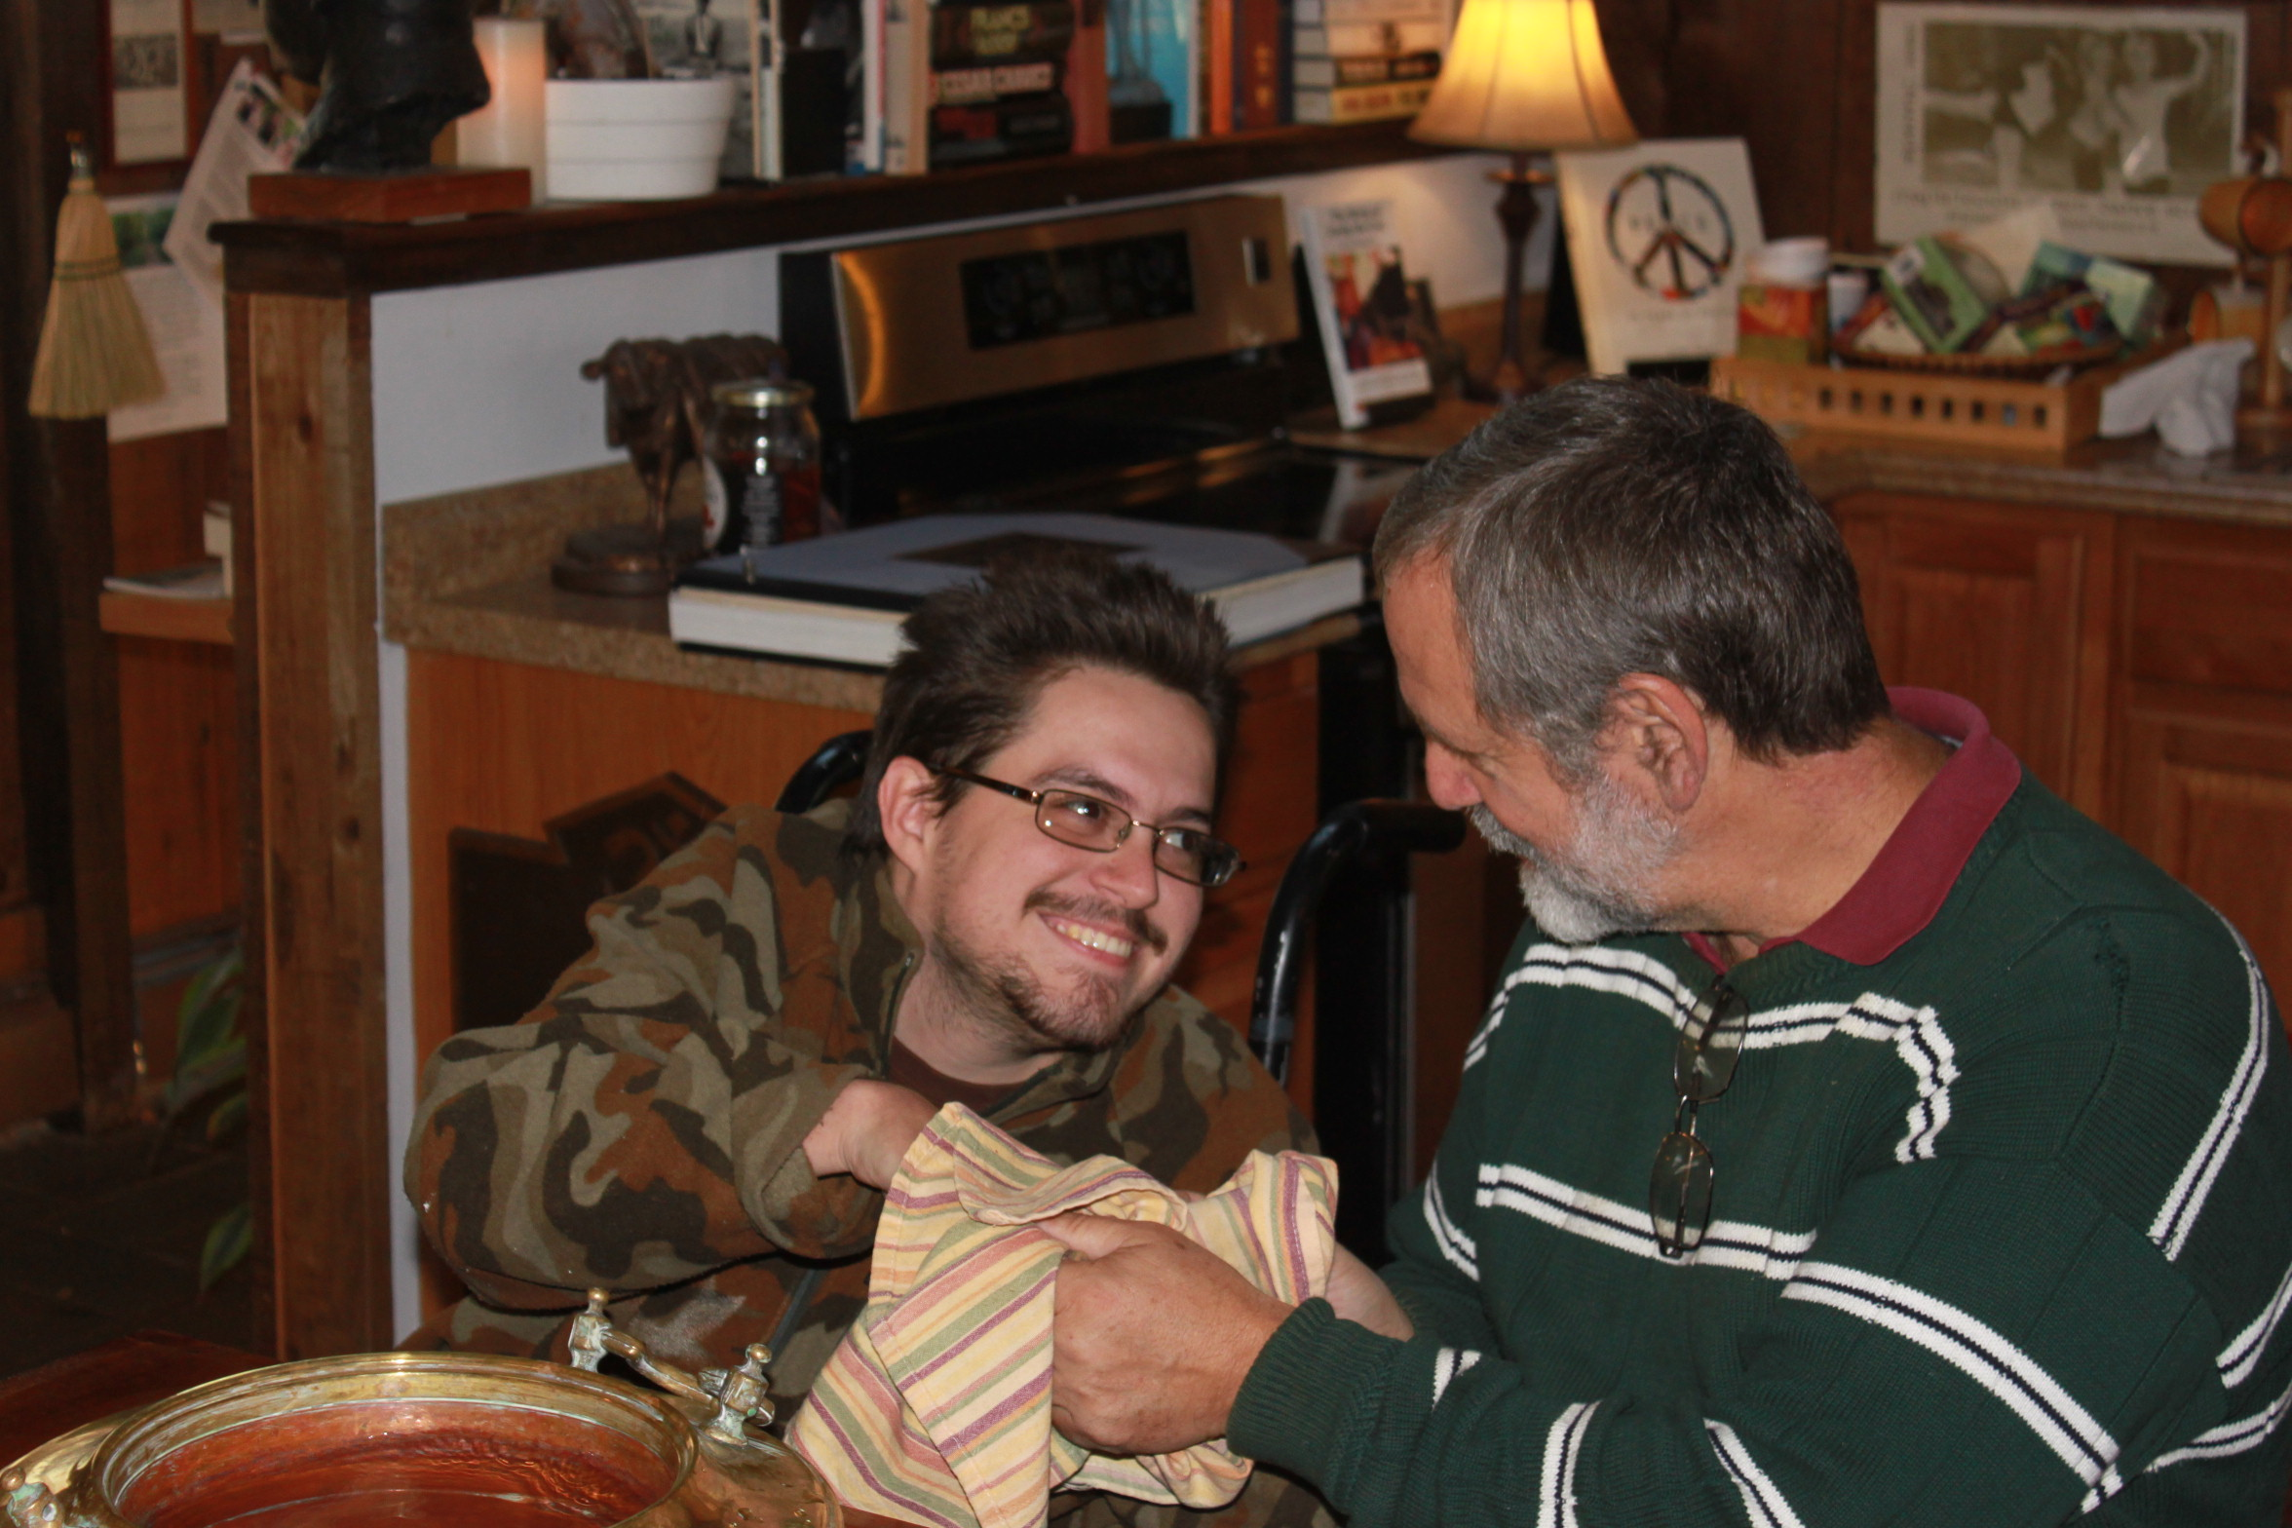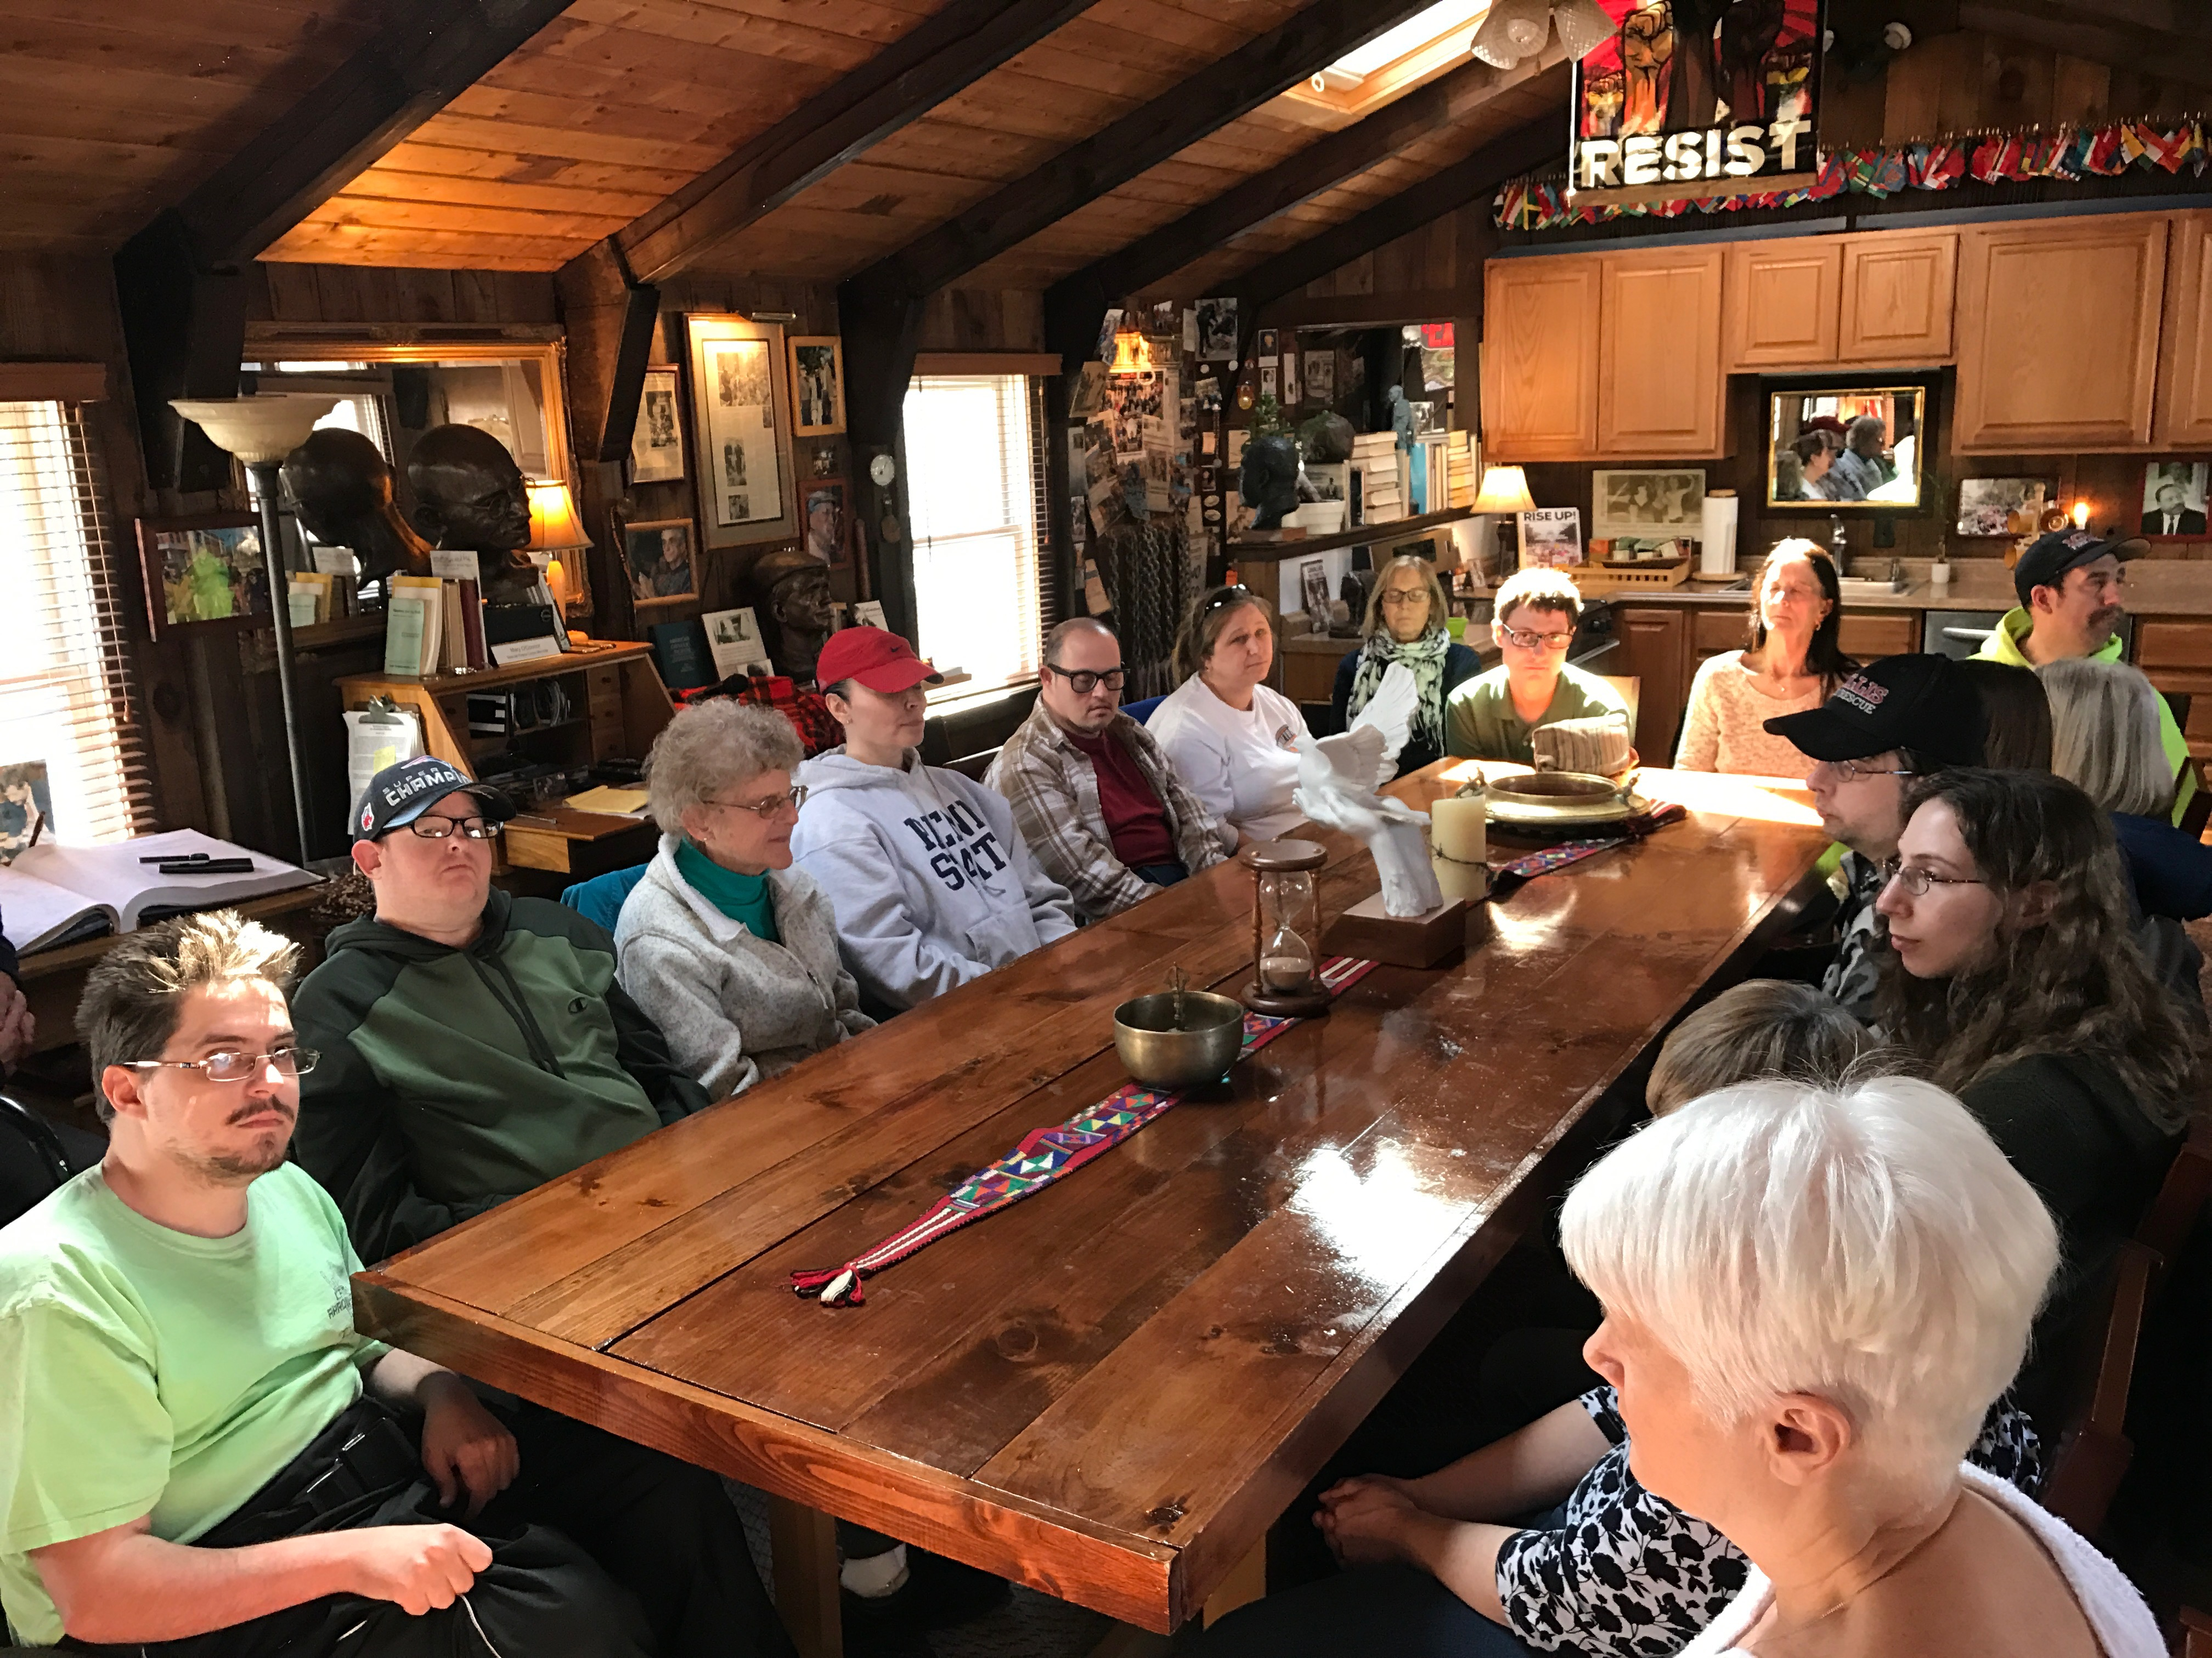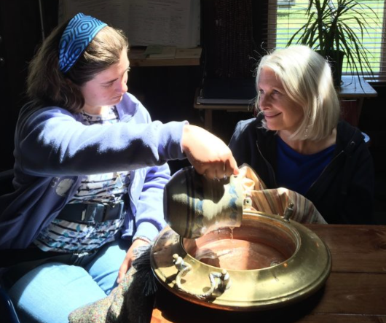

**Mission:** To offer young adults with special needs a unique opportunity to become actively involved in community service and actions for social justice.

**Our Creed:** *“When I am hungry, send me someone to feed; when I am thirsty, send me someone who needs a drink; when I am cold, send me someone to warm; when I am sad, send me someone to cheer; when I need understanding, send me someone who needs mine; when I need to be looked after, send me someone to care for; when I think only of myself, draw my thoughts to another.”*

**

*In loving memory of Paul, Jeff & Sandra.*

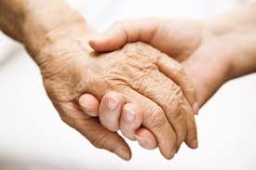

**

**

*To Make Gentle the Life of the World*

We believe that everyone learns best and finds personal fulfillment through positive and meaningful relationships. We have learned that our members mature more fully and reach their potential when assuming responsibilities as members of a caring, socially conscious community. Service to others puts life challenges in perspective and provides each member with a sense of mission throughout the day.

Life Experience

*Special Peace Corps*

*Established 1972*

## Our Peace Mission and Philosophy

A small, extended family day program for young adults

with disabilities

*To Make Gentle the Life of the World*

*Certified by the Massachusetts Department of Developmental Services*

Special Peace Corps

16 Lavender Street   
Millis, MA 02054  
508-376-4321 - www.lesmillis.org

The Life Experience School

LES members volunteer and participate in the community through:

* Vocational training at local schools, businesses, animal shelters and restaurants
* Participating in service projects in greater Boston
* Visiting area nursing homes and those in need
* Assisting local churches, ashrams and synagogues
* Receiving instruction in music, yoga, horseback riding, and more
* Affiliation with The Peace Abbey and its peace and social justice projects
* Delivering bread to nearby homeless shelters
* Individual endeavors include: assisting in music classes, operating a traveling paper shredding service, running their own bakery of horse treats and dog biscuits, photography, elder visits and animal care

*

The Life Experience School is a tax-exempt, nonprofit charitable organization.

*“My prayer is that The Life Experience School continues to prepare its students to become peacemakers in our troubled world – the true peace that comes from loving and caring and respecting the rights of everyone – my brother, my sister.”*

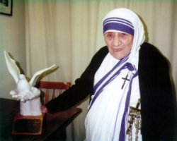

*Mother Teresa receives LES/Peace Abbey Humanitarian Award in 1989*

“At LES, each individual grows and learns in an atmosphere of dignity, trust and love.”

# Mother Teresa reflects on LES during 1988 visit: